DECISION

No. 280, dated 17.4.2026

ON THE FORM, METHOD AND PROCEDURE FOR REPORTING THE DATA OF THE STATE CADASTRE AGENCY

Pursuant to Article 100 of the Constitution and point 1 of Article 28 of Law no. 9917, dated 19.5.2008, “On the prevention of money laundering and financing of terrorism”, as amended, upon the proposal of the Minister of Finance, the Council of Ministers

DECIDED:

1. This decision determines the form, manner and procedure of reporting, which must be applied by the State Cadastre Agency, according to the provisions in Law no. 9917, dated 19.5.2008, “On the prevention of money laundering and financing of terrorism”, as amended.
2. The terms used in this decision have the same meaning as the terms defined in Law no. 9917, dated 19.5.2008, “On the prevention of money laundering and terrorist financing”, as amended.
3. For the purpose and implementation of this decision, the following terms have these meanings:
a) “Suspicious activity report” (SAR), the form that the reporting subject, the State Cadastre Agency, reports to the responsible authority, the Financial Intelligence Agency, for any suspicion, information or data on money laundering or terrorist financing, for the activity under its jurisdiction, according to annex I, which is attached to this decision and is an integral part thereof;
b) “Transaction report of values” (RTV), the form that the reporting entity, the State Cadastre Agency, is obliged to complete and report, within 72 (seventy-two) hours, the registration of the contract for the transfer of property, with a value equal to or greater than 6 000 000 (six million) lek or its equivalent in other foreign currencies, according to annex II, which is attached to this decision and is an integral part thereof.
4. The State Cadastre Agency reports to the responsible authority, the Financial Intelligence Agency, within 72 (seventy-two) hours, the registration of the contract for the transfer of property, with a value equal to or greater than 6 000 000 (six million) lek or its equivalent in other foreign currencies, according to the RTV form.
5. The State Cadastre Agency reports immediately and no later than 72 (seventy-two) hours to the responsible authority, the Financial Intelligence Agency, any suspicion, information or data on money laundering or terrorist financing for the activities under its own jurisdiction, according to the RAD form.
6. Reporting, according to the requirements of the RTV and RAD forms, is carried out electronically, according to the formats specified in this decision.
7. In implementation of this decision, the Director General of the State Cadastre Agency:
a) appoints in the general directorate a person to serve as a contact person for the responsible authority, the Financial Intelligence Agency;
b) appoints a person responsible for the prevention of money laundering and the financing of terrorism, at the administration or management level in the general directorate and in each of its local directorates, where all employees of the State Cadastre Agency report any fact, which may constitute suspicion of money laundering or financing of terrorism;
c) organises the monitoring process and ensures the performance of the duties defined by the law on the prevention of money laundering and the financing of terrorism;
c) charges internal control to monitor the implementation of legal obligations by the designated responsible persons for reporting, in accordance with the legal provisions in force and this decision;
d) takes administrative measures and cooperates with the responsible authority, the Financial Intelligence Agency, for the preparation and organisation of periodic training of the responsible persons of the State Cadastre Agency, for the prevention of money laundering and financing of terrorism, as well as the respective typologies related to these fields.
8. The responsible person has these competencies and duties:
a) Analyses any data or information that has been reported as suspicious, or has been identified through the employees of the State Cadastre Agency, for the purpose of sending the STR to the Financial Intelligence Agency;
b) Receives any information necessary to fulfil the functions, in accordance with the law and this decision;
c) Sends the RAD to the Financial Intelligence Agency, if the information is assessed as suspicious;
c) Maintains confidentiality in the activity carried out, in compliance with the law and this decision;
d) The responsible person takes measures for the implementation of the preventive measures determined in Law no. 9917, dated 19.5.2008, “On the prevention of money laundering and financing of terrorism”, as amended;
dh) Prepare a written report, at least 1 (one) time a year, on the monitoring process, in which it also includes the number of suspicious activity reports identified and submits it to the General Director of the State Cadastre Agency.
9. The responsible person and every employee of the State Cadastre Agency are prohibited from informing the person or any other person about the sending or preparation for sending of the information to the responsible authority, the Financial Intelligence Agency, on the reporting of suspicious activity, as well as about any information requested by the responsible authority or about the investigations that are being carried out.
10. The State Cadastre Agency responds to the requests of the responsible authority, no later than within 10 (ten) calendar days from receipt of the request for information.
11. When the responsible authority, the Financial Intelligence Agency, has frozen or is preparing to freeze a transaction for 72 (seventy-two) hours, according to the provisions of the law, or in urgent cases when there are reasonable grounds for money laundering or terrorist financing and there is an urgent need for information from the State Cadastre Agency, the responsible authority shall address the State Cadastre Agency officially in written form. Also, this request within the working day must also be transmitted digitally online, in accordance with the provisions of decision no. 389, dated 13.5.2020, of the Council of Ministers, “On the approval of the list and the fees of cadastral services”, as amended.
The State Cadastre Agency makes available to the responsible authority the requested information or documentation, within 48 (forty-eight) hours from the submission of the request, or through inspection of the information on the premises of the State Cadastre Agency by authorised persons of the responsible authority.
12. The State Cadastre Agency, in implementation of letter “b”, of Article 22, of Law no. 9917, dated 19.5.2008, “On the prevention of money laundering and terrorist financing”, as amended, and of point 6, of Article 28, of Law no. 111/2018, “On cadastre”, and the bylaws issued in implementation thereof, provides direct access to the database to the responsible authority, the Financial Intelligence Agency. Requests for cadastral services (request for information and documentation) are provided after submission of the request by digital means online, in accordance with the provisions of Article 63, of Law no. 111/2018, “On cadastre”, being subject to the procedures provided for in Decision no. 389, dated 13.5.2020, of the Council of Ministers, “On the approval of the list and fees of cadastral services”, as amended.
13. This decision, together with Annexes I, II and the respective instructions, are the only acceptable standards for reporting to the responsible authority.
14. Guideline no. 1, dated 1.4.2009, of the Council of Ministers, “On the form, methods and procedures for reporting the data of entities, the Agency for the Legalisation, Urbanisation and Integration of Informal Areas/Constructions and the Central Office for the Registration of Immovable Properties, in the framework of the prevention of money laundering and terrorist financing”, is repealed.
15. The State Cadastre Agency and the Financial Intelligence Agency are charged with the implementation of this decision.
This decision enters into force after publication in the Official Gazette.

DEPUTY PRIME MINISTER
Albana Koçiu

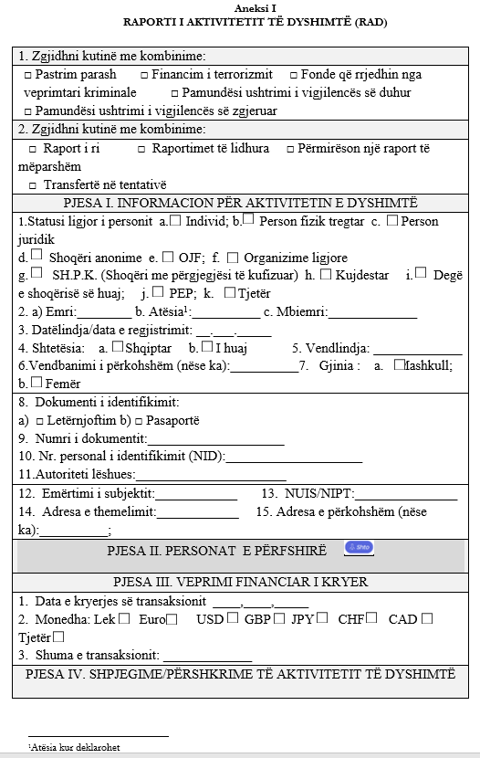

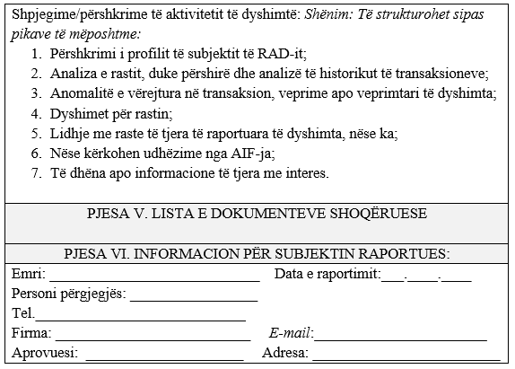

INSTRUCTIONS
FOR THE COMPLETION OF THE FORM
“SUSPICIOUS ACTIVITY REPORT” (SAR)

INTRODUCTION

“Suspicious activity report” (SAR) is the form attached to this decision, by means of which the subject reports to the responsible authority every suspicious transaction and activity. This form is completed by the subject for cases when they know or suspect that the laundering of proceeds of crime and the financing of terrorism is being carried out, has been carried out or is attempted to be carried out, or that the funds involved derive from criminal activity.
Reporting shall be done by means of the form (RAD) immediately and no later than 72 (seventy-two) hours.
1. A cross is marked in the corresponding box, as the case may be, if the activity is suspected to be related to money laundering, financing of terrorism or the funds derive from criminal activity.
2. A cross is marked in the corresponding box, as the case may be, if a new report, an attempted transfer, or an improvement of a previous report is sent to the FIU.
PART I. INFORMATION ON SUSPICIOUS ACTIVITY
1. The legal status of the person: By selecting one of the boxes, the reporting subject provides information on the legal status of the person(s) involved in the suspicious activity, as applicable, individual, natural person trader, legal person, joint-stock company, NGO, legal arrangements, LLC (limited liability company), guardian, branch of the foreign company, others.
2. First name, father's name, surname: For the individual, the first name, father's name and surname are written. The father's name is completed when declared.
3. Date of birth/date of registration (dd.mm.yyyy): If the person, in whose name the transaction(s) is/are carried out, is an individual, write the date of birth, otherwise the date of registration of the company shall be written. The date is written in eight-digit format. The first two digits indicate the calendar date of the month, the second two indicate the calendar month and the last four indicate the year of birth. Zero (0) must precede every single digit. E.g. if the date of birth of an individual is 3 April 1978, in the report must be written in the format 3.4.1978.
4. Nationality: The nationality of the person carrying out the transaction is written (completed in the case of natural persons).
5. Place of birth: The place (jurisdiction) where the person was born is written.
6. Temporary residence (if any): To be completed if the person has a place where he is located in order to perform certain work or duties, to attend a certain school or course, to receive medical treatment, to serve a criminal sentence, and for other cases of this nature.
7. Gender: a) Male; b) Female: A cross is marked in the corresponding box, as the case may be, whether the individual is male or female.
8. Identification document: a) □ identity card; b) □ passport; c) □ personal no. (NID);
A cross is marked in the corresponding box, according to the type of document used, to carry out the identification of the person.
9. Document number: Here is written the number of the document used for identification, as well as the personal number.
10. Personal identification number. The personal identification number is written here.
11. Issuing authority: Here is written the state authority that issued the document used to carry out the identification of the person.
12. Name of the entity: Here the name of the entity is written.
13. NUIS/NIPT: The unique identification number of the entity or the identification number of the taxable person is written.
14. Address of establishment: The full address of the central office of the person involved in the suspicious activity is written.
15. Temporary address (if any): Completed if the person has a place of business different from the address of establishment.
PART II. PERSONS INVOLVED
In this part of the report, data are provided on the persons involved in the transaction.
PART III. FINANCIAL ACTION CARRIED OUT
1. Date of carrying out the transaction: The date of the transaction is written in the eight-digit format. The first two digits indicate the calendar date of the month, the second two indicate the calendar month and the last four indicate the year. Zero (0) must precede every single digit, e.g. if the date of the transaction is 5 May 2008, in the report it must be written 5.5.2008.
2. Currency: Put a cross in one of the boxes, according to the type of currency used for carrying out the transaction, e.g.: LEK, USD, GBP, EUR etc.
3. Amount of the transaction: The amount in lek is written for a single transaction or for several transactions linked to one another.
PART IV. EXPLANATIONS/DESCRIPTIONS OF THE SUSPICIOUS ACTIVITY
In this part of the report, the reporting entity provides a description of the activity and the reasons for suspicion. The character limit has been set to ensure the updating of voluminous information, which enters the database, e.g.: table, figure, the materials for this limit may be transmitted compressed in zip format to part V, as follows.
PART V. LIST OF ACCOMPANYING DOCUMENTS
In this part of the report, the documents accompanying the report are uploaded in zipped form (up to 10.MB ZIP).
PART VI. INFORMATION ON THE REPORTING ENTITY
In this part of the report, the data regarding the reporting entity are written, such as: the name of the person responsible for the prevention of money laundering or the name of the person who approves the RAD report (in cases when it is different from the responsible person), the reporting date in the format (dd.mm.yyyy), as well as the telephone number/address of the email-it, as well as the address of the responsible person, by means of which the responsible authority may give further instructions regarding the submitted report.

ANNEX II
REPORT OF THE SECURITIES TRANSACTION (RTV)
(in a value equal to or greater than 6 million lekë)

Choose the appropriate box:
- New reporting | - Improves a previous report
- Included are more than one individual/company |  | - Related transactions

PART I. PARTIES INVOLVED IN THE TRANSACTION
SECTION A – THE SELLING/DONATING/OTHER PARTY

a) Name__________________ | b) Surname__________________
c) Name of the entity ____________________ ç) NID/NUS ________________________

d) The due part _____________________

SECTION B
THE BUYING/DONEE/OTHER PARTY

a) Name__________________ | b) Surname__________________
c) Name of the entity ____________________ ç) NID/NUS ________________________

d) The corresponding part _____________________

PART II. INFORMATION ON THE TRANSACTION/S

Rep. No.: ___________ |  |  |  | No. col.: _____________ |  |  | Date of the transaction: ___.____.______
Date of transfer of ownership: ______________________
Type of property (apartment, field, etc.) ________________
Area: _________________
Property address: _____________________________
Property no.:__________________________________
Cadastral zone:_______________________________

Amount: ____________ |  |  |  |  | Choose the currency: | LEK |  | EUR | USD | Other ______

PART III. INFORMATION ON THE REPORTING ENTITY

a) Name__________________ |  |  | b) Surname_________________
c) Name of the institution ______________________________________________________

Address: __________________________________________________________________________
Responsible person: |  | _____________________________________________________________
Reporting date: ___.____.______ |  |  |  |  | Tel: ___________________________________
Address e-mail address:
(NIPT): _______________________________

TO BE COMPLETED IF MORE THAN ONE INDIVIDUAL/COMPANY ARE INVOLVED IN THE TRANSACTION
PART I. PARTIES INVOLVED IN THE TRANSACTION
SECTION A – THE SELLING PARTY

a) Name__________________ | b) Surname__________________
c) Name of the entity _________________ ç) NID/ NUS ________________________

d) The corresponding share _____________________

SECTION B – THE PURCHASING PARTY

a) Name__________________ | b) Surname__________________
c) Name of the entity ____________________ ç) NID/ NUS ________________________

d) The due part _____________________

PART II. INFORMATION ON THE TRANSACTION/SACTIONS

No. ref.: ___________ |  |  |  | No. col.: _____________ |  |  | Date of the transaction: ___.____.______
Type of transaction: ___________________

Type of property, subject of the contract/transaction: ___________________

Amount: ____________ |  |  |  |  | Choose the currency: | LEK |  | EUR | USD | Another ______

PART III. INFORMATION ON THE REPORTING ENTITY

a) Name__________________ |  |  | b) Surname_________________
c) Name of the institution ______________________________________________________

Address: __________________________________________________________________________
Responsible person: |  | _____________________________________________________________
Reporting date: ___.____.______ |  |  |  |  | Tel: ___________________________________
Address e-mail-i:
(NIPT): _______________________________

